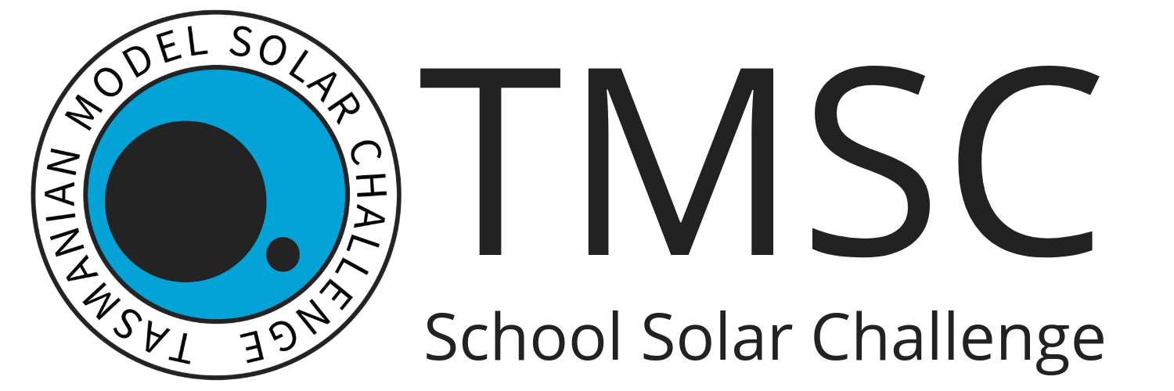

TMSC Media Policy

NOTE: Please complete and return this form when registering for a Tasmanian Model Solar Challenge competition if you do not wish to have any photographs or video footage containing you or your child included in any possible material later published by the TMSC following an event.

- By competing in a TMSC event, I understand that it is likely that I and/or my child may be photographed or filmed by the TMSC, the media or any other individuals at the competition.
- I do not grant the TMSC permission to use my name and image or the name and image of my child in any later material, including, but not limited to, event social media, newsletters, websites, etc.
- I accept that this only applies to any material that the TMSC has control over. The TMSC cannot prevent the release of any photographs or video footage taken by other parties/individuals at an event.

School

Student’s Name

Parent’s/Guardian’s Signature

Date

Please return to miseli@utas.edu.au prior to the event or bring along a signed copy when scrutineering on the day.

